ITA0601 – MACHINE LEARNING
LAB EXPERIMENTS
Exp-5: Implementation of K-Nearest Neighbours (K-NN) in Python
Aim:
To implement the K-Nearest Neighbours (K-NN) algorithm using Python and classify test samples using an appropriate dataset.
Procedure:
- Import the required libraries.
- Load the Wine Dataset from scikit-learn.
- Split the dataset into training and testing sets.
- Standardize the input features.
- Create the K-NN classifier with K = 3.
- Train the classifier using the training dataset.
- Predict the class labels for the test dataset.
- Display the accuracy, confusion matrix, and classification report.
Python Code:
from sklearn.datasets import load_wine
from sklearn.model_selection import train_test_split
from sklearn.preprocessing import StandardScaler
from sklearn.neighbors import KNeighborsClassifier
from sklearn.metrics import accuracy_score, confusion_matrix, classification_report
wine = load_wine()
X = wine.data
y = wine.target
X_train, X_test, y_train, y_test = train_test_split(
X, y, test_size=0.2, random_state=42
)
scaler = StandardScaler()
X_train = scaler.fit_transform(X_train)
X_test = scaler.transform(X_test)
knn = KNeighborsClassifier(n_neighbors=3)
knn.fit(X_train, y_train)
y_pred = knn.predict(X_test)
print("Accuracy:", accuracy_score(y_test, y_pred))
print("\nConfusion Matrix:")
print(confusion_matrix(y_test, y_pred))
print("\nClassification Report:")
print(classification_report(y_test, y_pred))
Output:
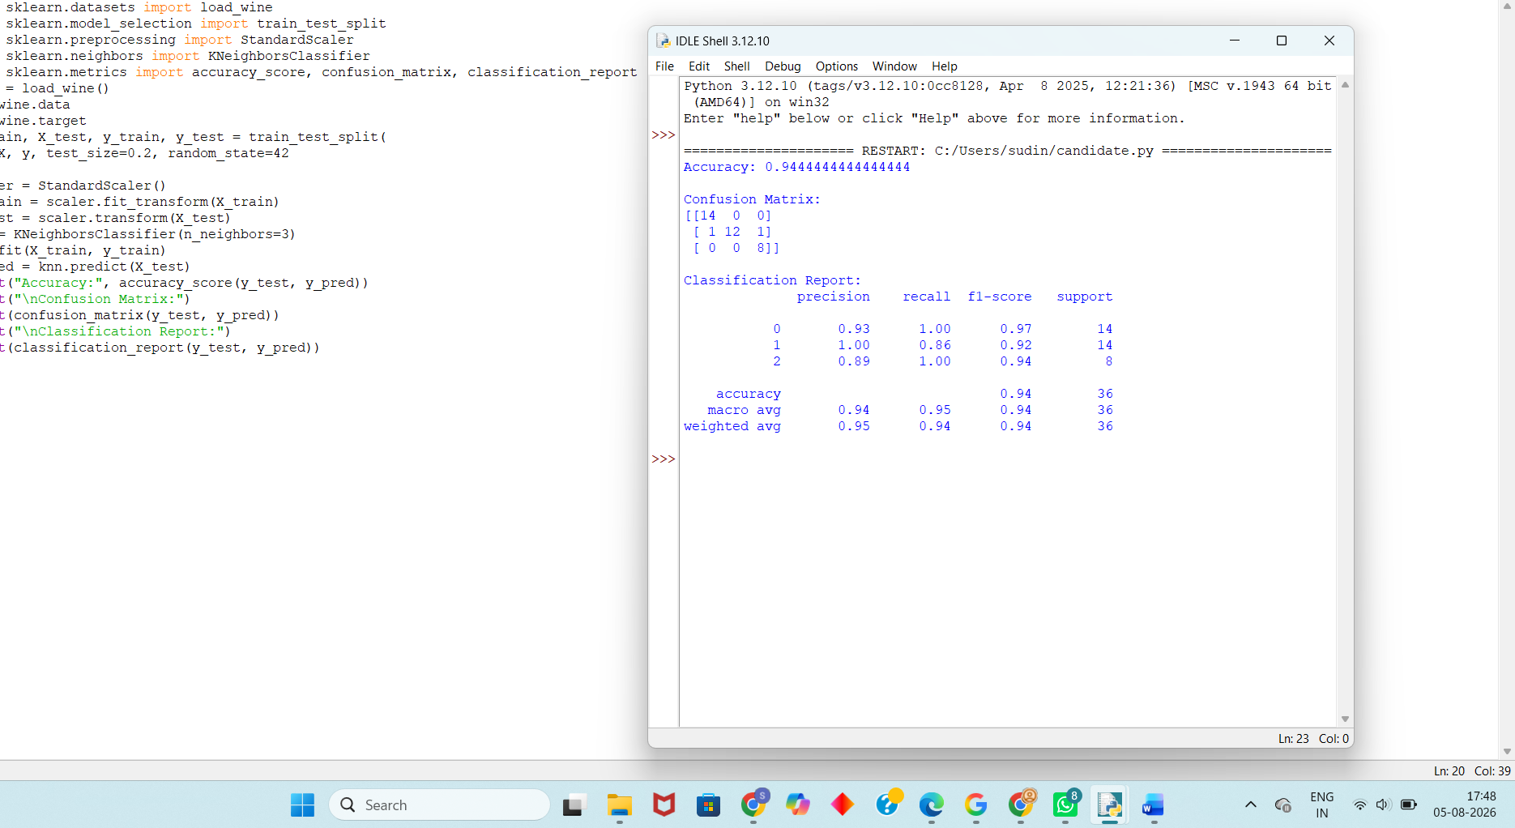
Result:
The K-Nearest Neighbours (K-NN) algorithm was successfully implemented using Python. The model was trained and tested on the Wine Dataset, achieving high classification accuracy. The confusion matrix and classification report confirmed the effectiveness of the K-NN classifier.

